Job 5 . A

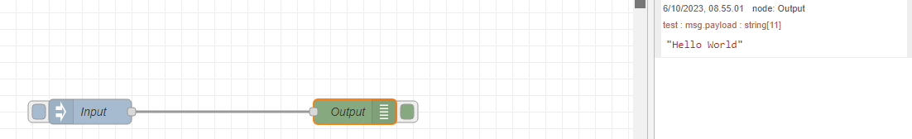

Job 5.B.a

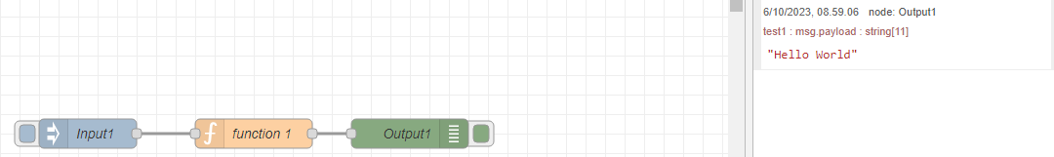

Job 5.B.b

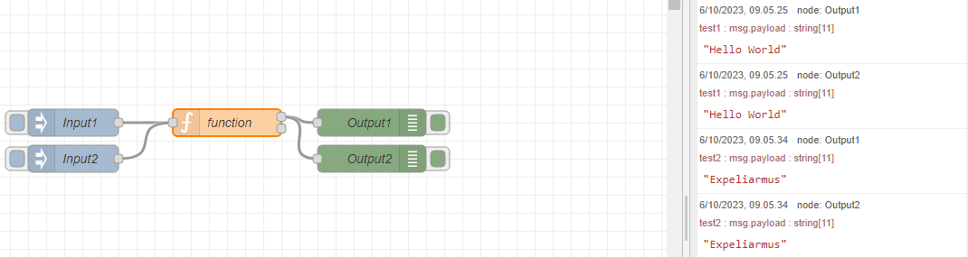

Job 5.C

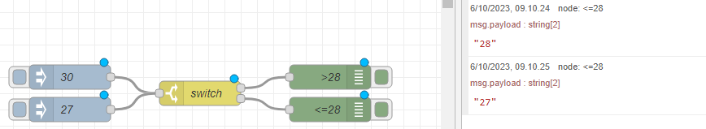

Job 5.d

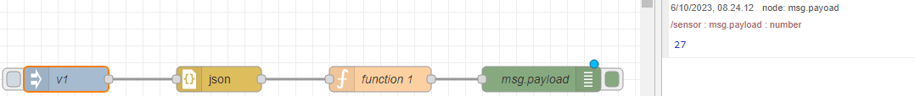

Job 5 pertanyaan

